# MySQL Setup and installation

We will be installing the following:

1. MySQLWorkbench (<https://dev.mysql.com/downloads/workbench/>)
2. MySQL (<https://dev.mysql.com/downloads/installer/>)

## Installing MySQLWorkbench

Download and open the file named “mysql-workbench-community-8.0.16-winx64”. You should see the following:

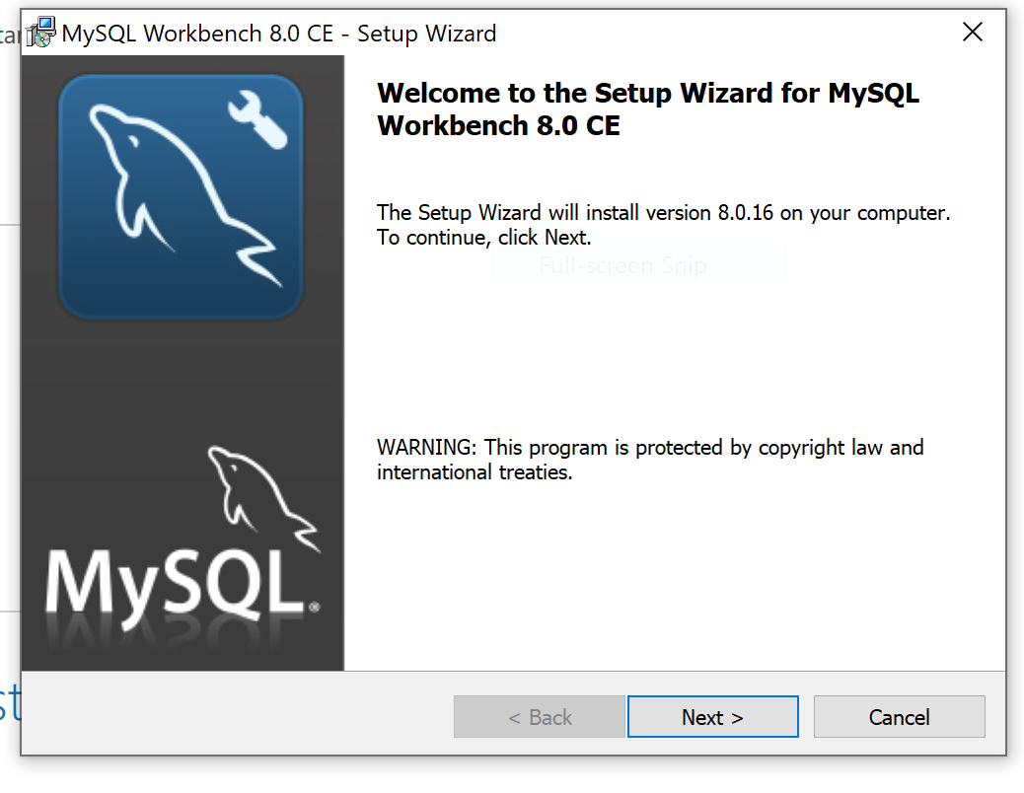

Click **Next** and use the default configurations for the rest of the setup.

Ensure that the setup type is **Complete** instead of **Custom**:

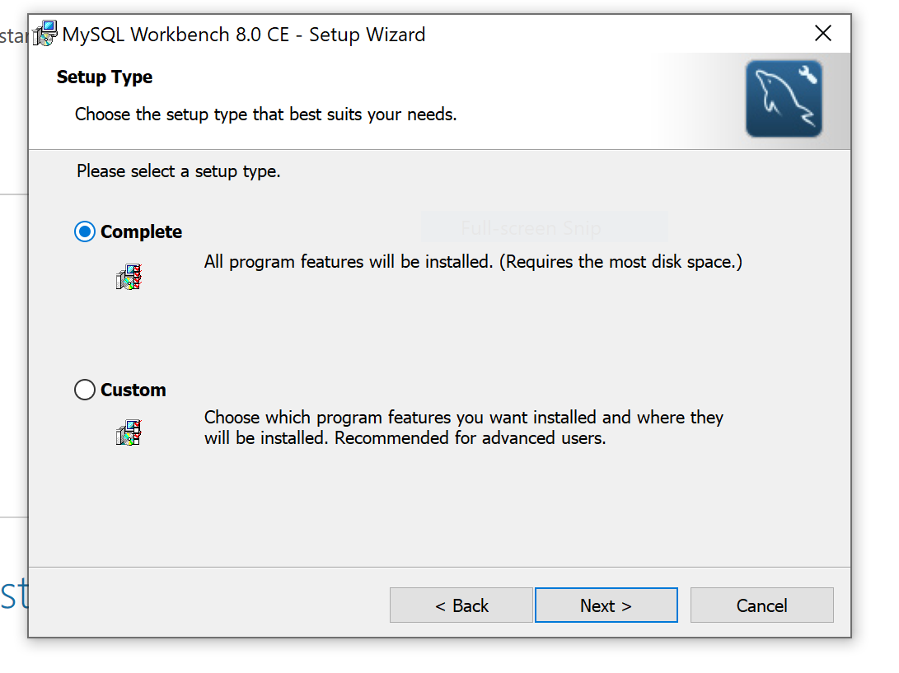

Once the installation is done, close the setup wizard.

## Installing MySQL

Download and open the file named “mysql-installer-web-community-8.0.16.0”. You should see the following:

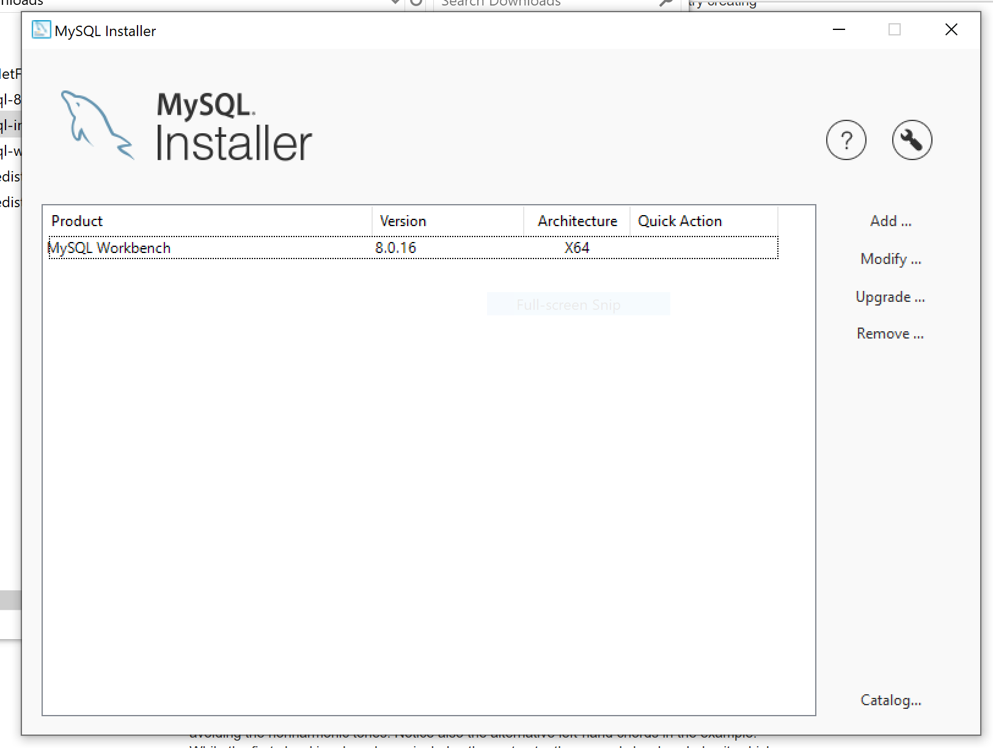

Click on **Add…**\*. Accept the license agreement.

In the Select Products and Features, just the green right arrow to move MySQL Server 8.0 to the “Products/Features To Be Installed” section:

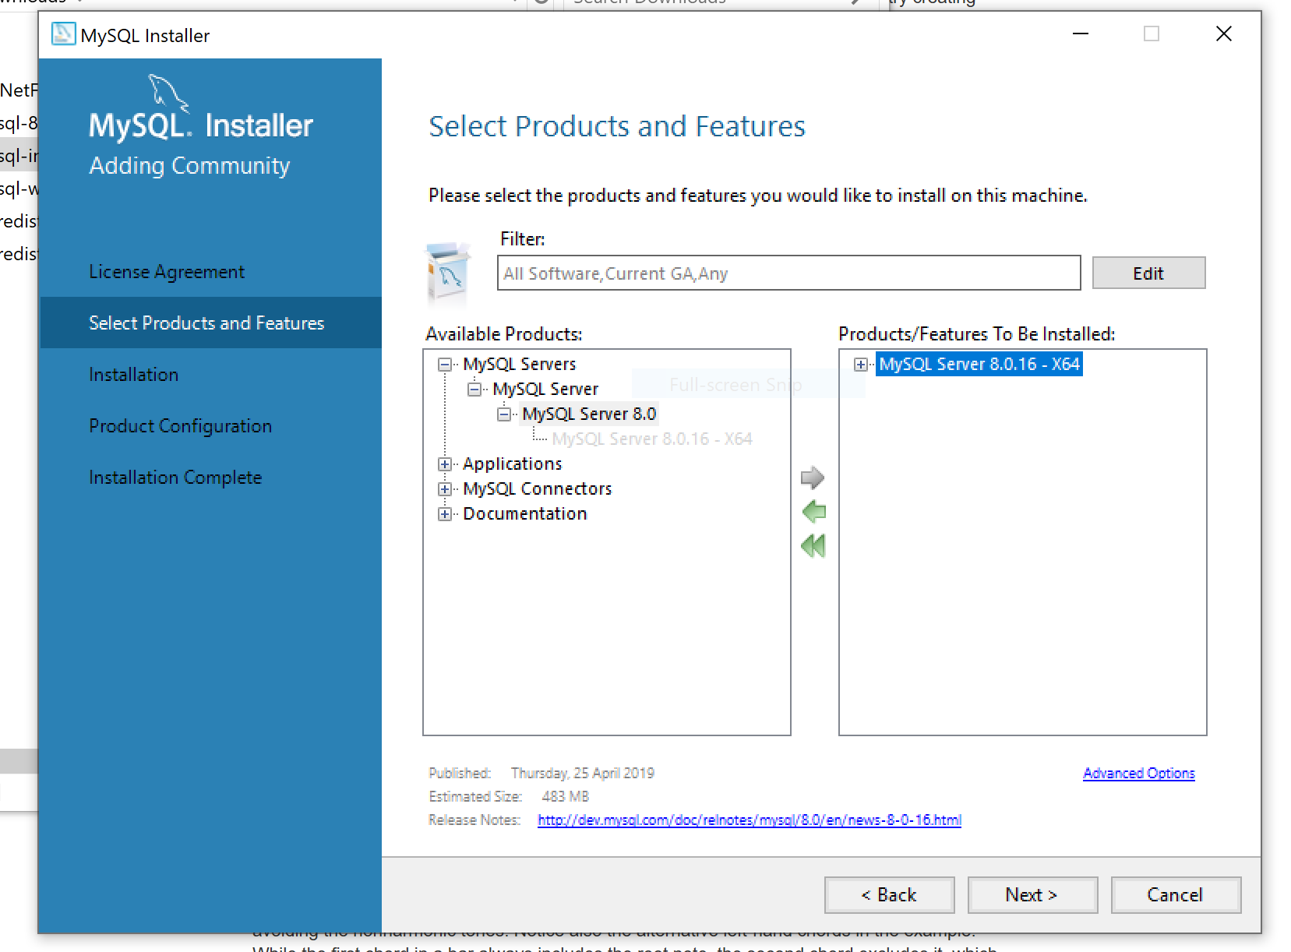

Click on **Next** to continue. The MySQL 8 installer will be downloaded. Follow the default configuration until Product Configuration:

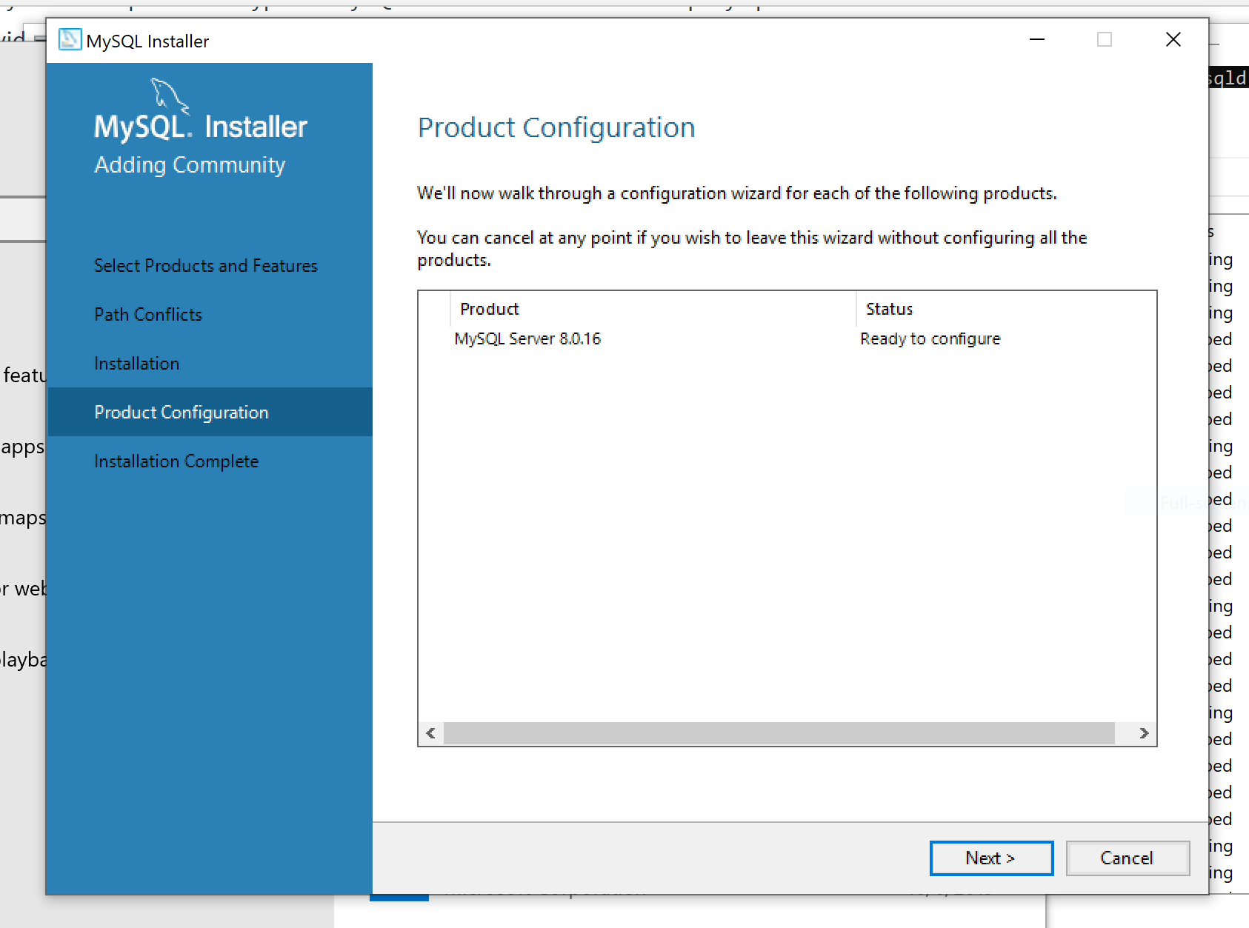

Click on **Next**.

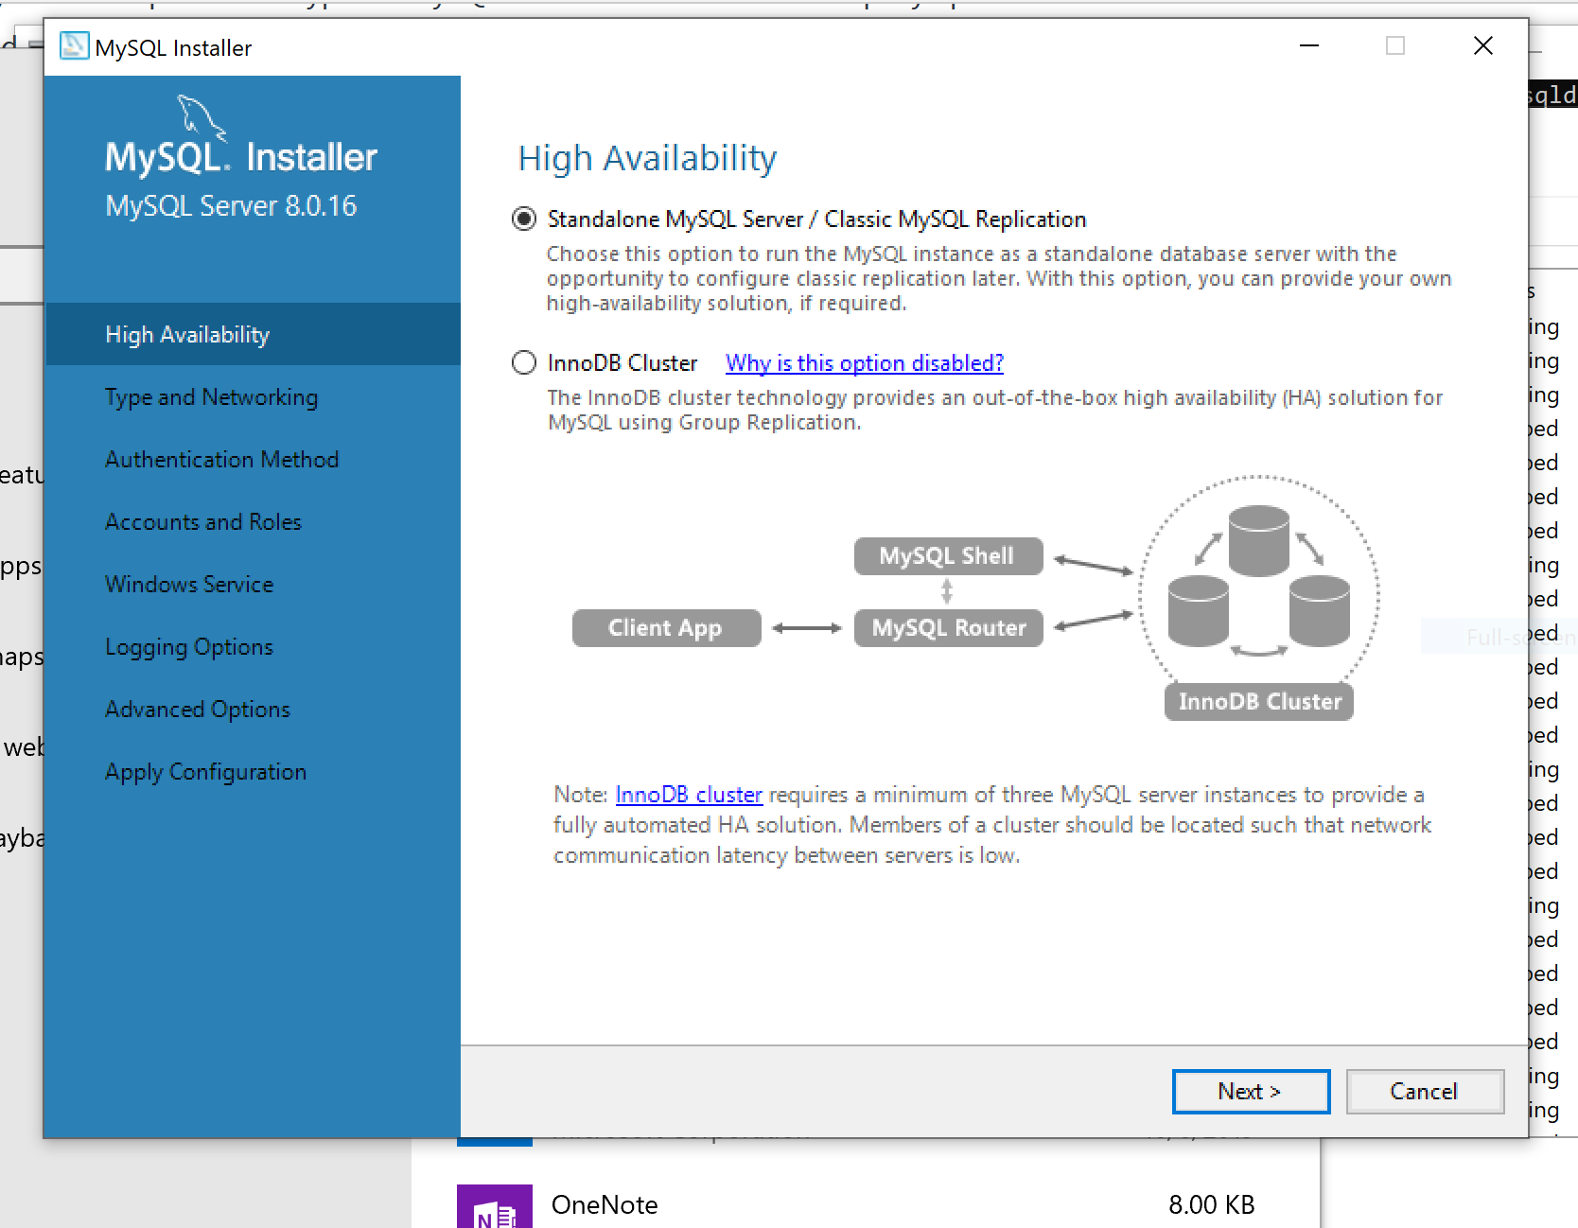

Ensure that Standalone MySQL Server option is selected and click on **Next**.

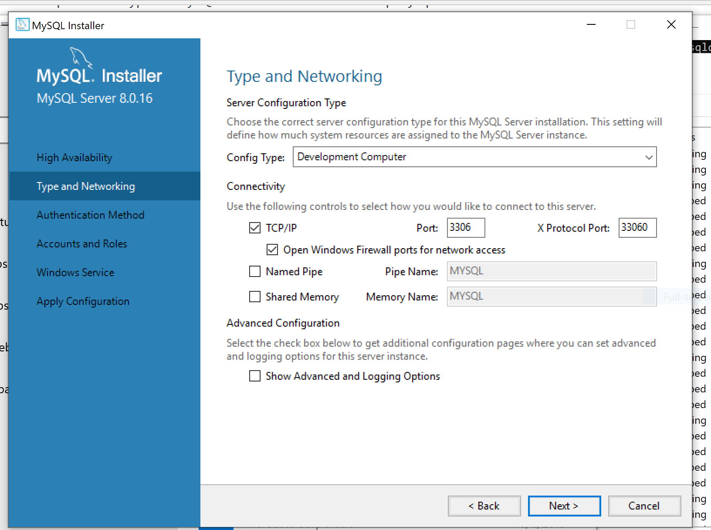

Go with the default configuration for Type and Networking and click on **Next**.

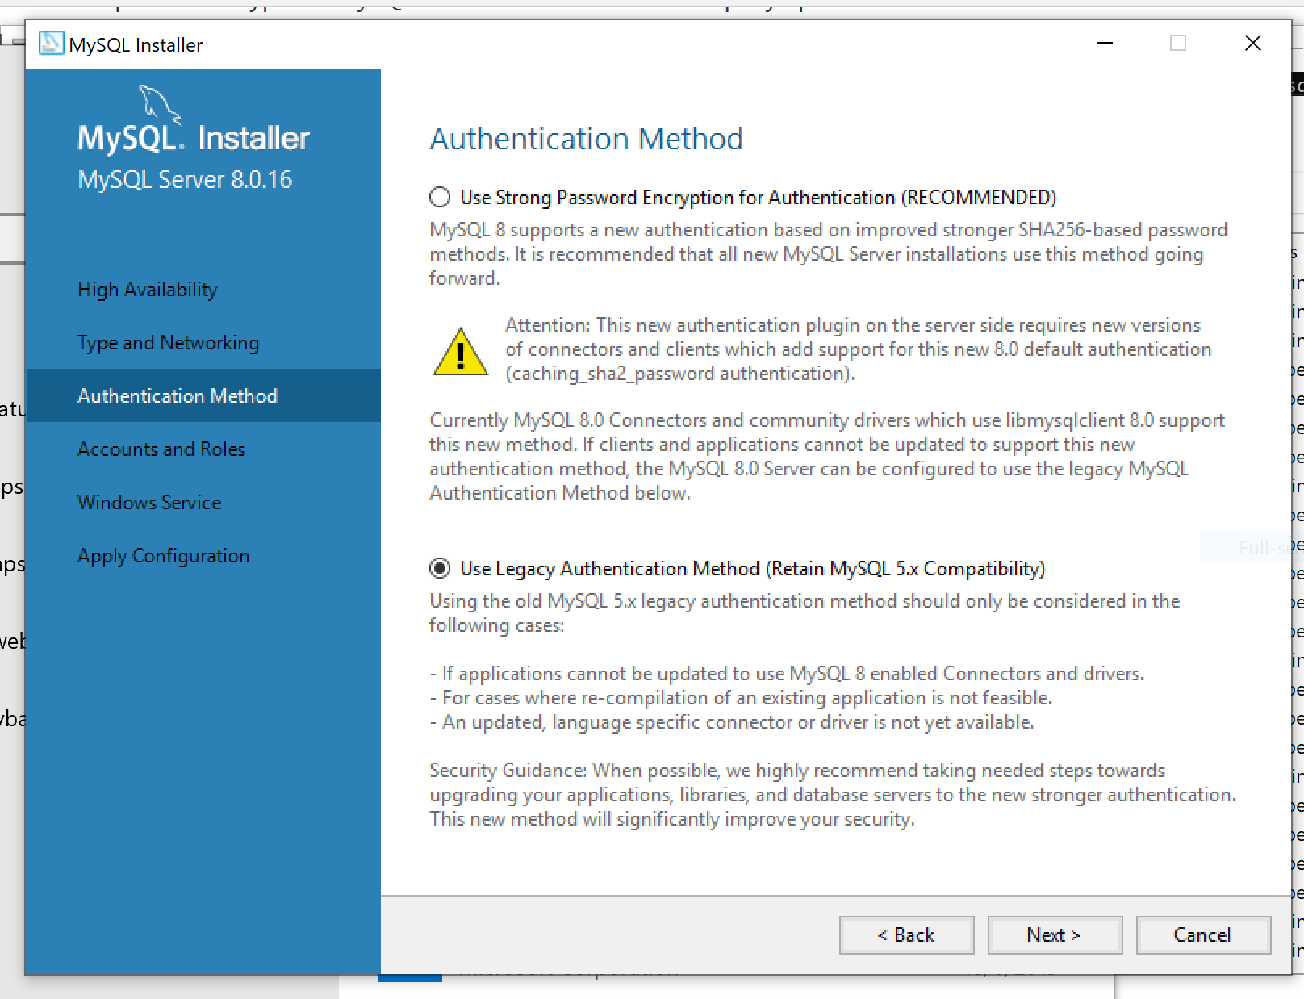

Select the legacy authentication method for Authentication Method and click on **Next**. We are using the legacy authentication because at the time this document is written, the new authentication method is still not supported by the default MySQL library for Node.js.

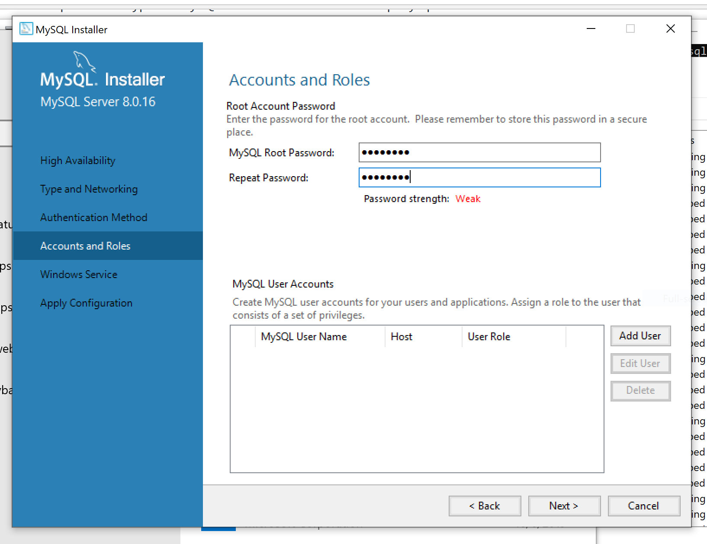

Make sure to type in a secure password and **remember** it! We will need the password to connect to the database.

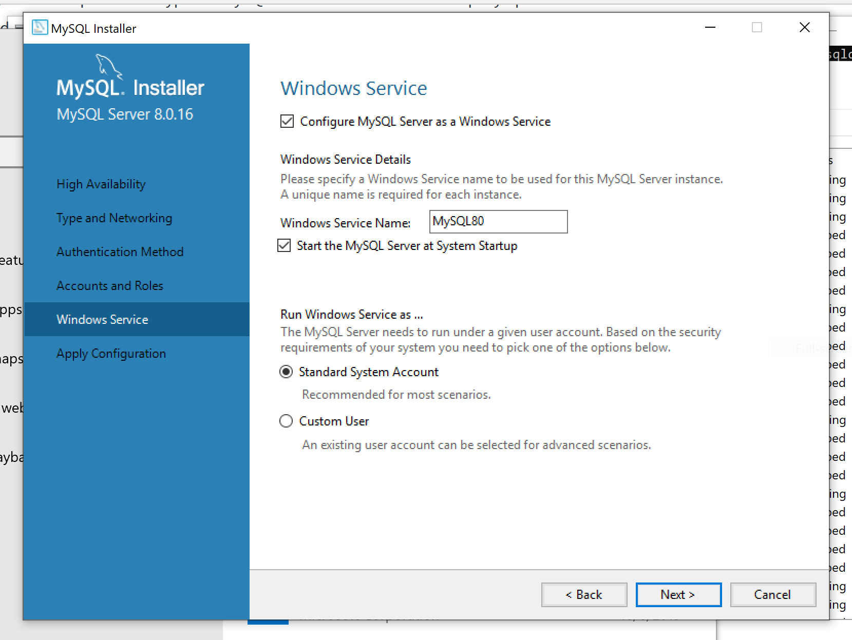

Under Window Service, go with the default configuration and click on **Next**.

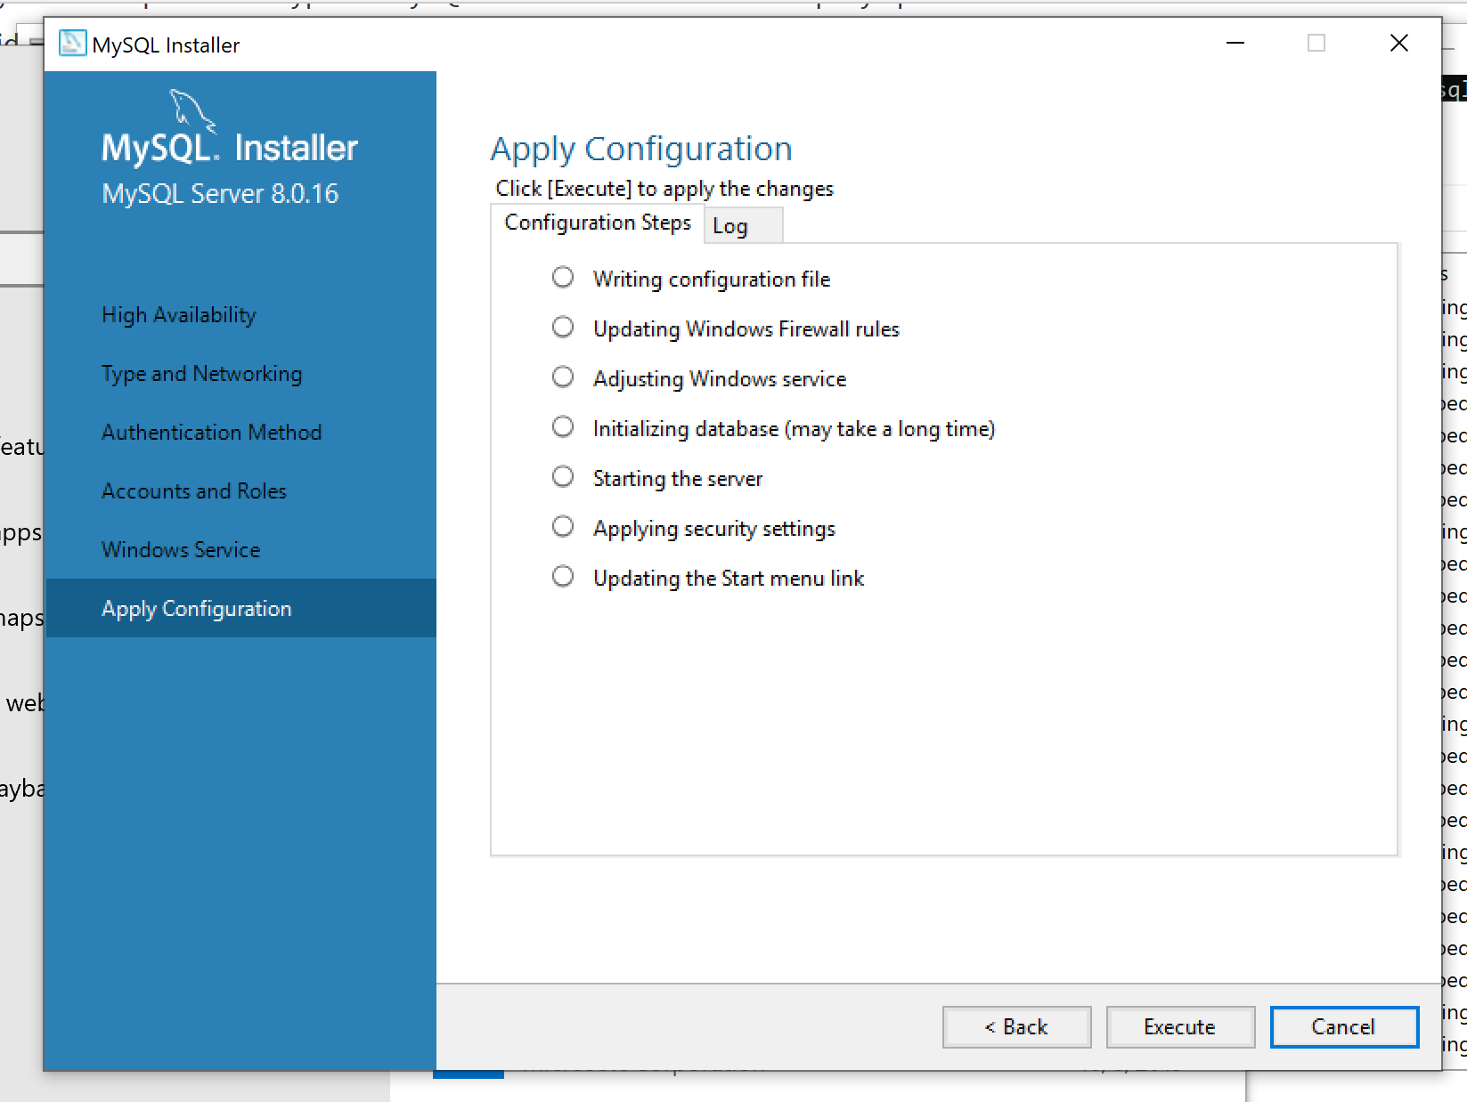

Click on **Execute**. Once it is done, click on **Finish**.

## Connecting to the database from MySQLWorkbench

We will now connect to the MySQL database server we just installed.

Open MySQLWorkbench. You should see the following:

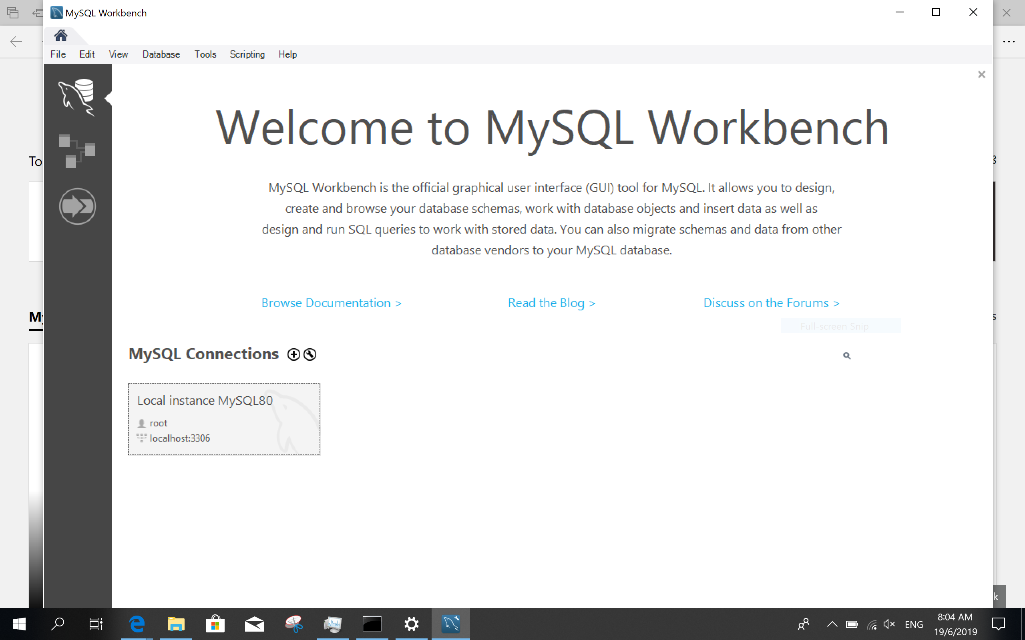

Click on the Local instance MYSQL80 connection. You will be prompted to enter a password:

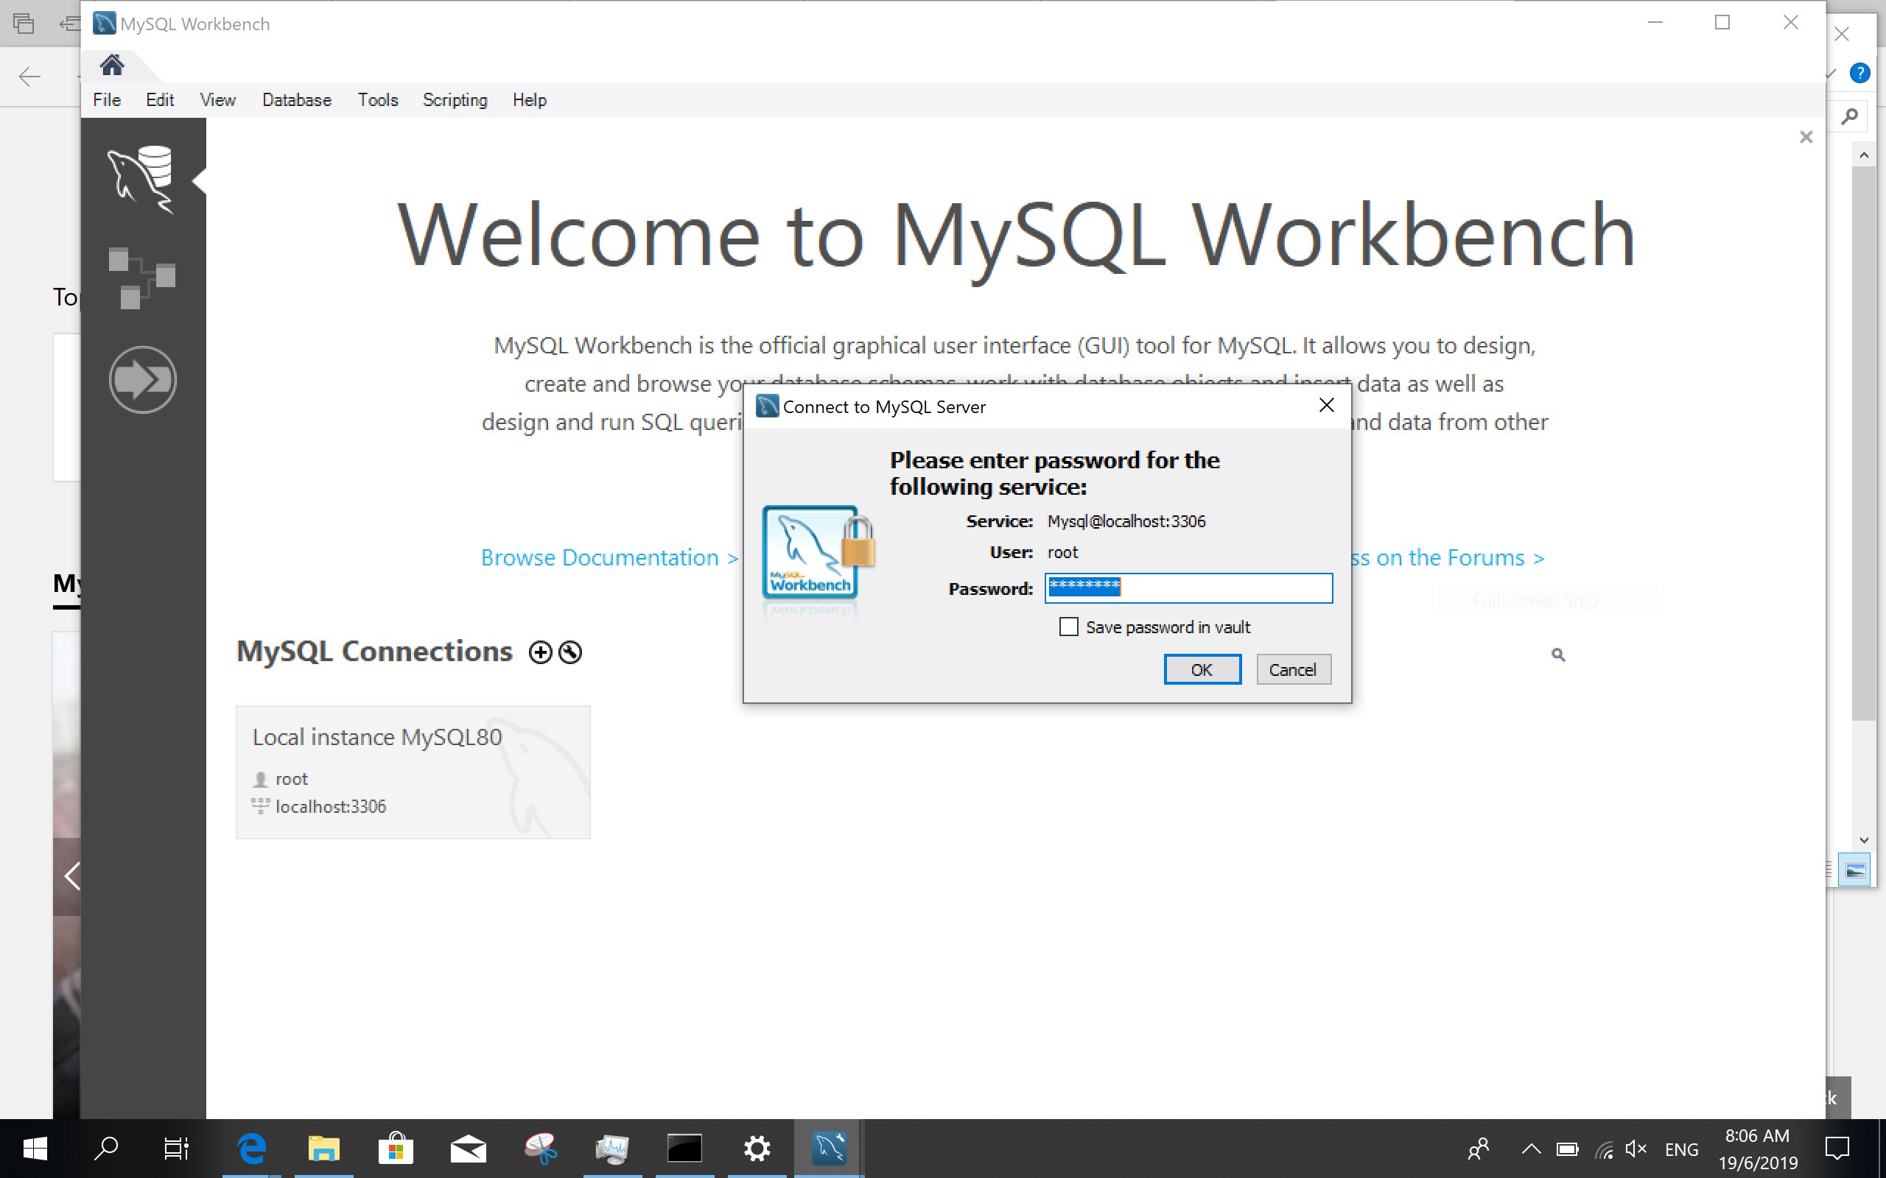

Enter the password you previously set for the MySQL server and click on **OK**. Once the login is successful you will be brought here:

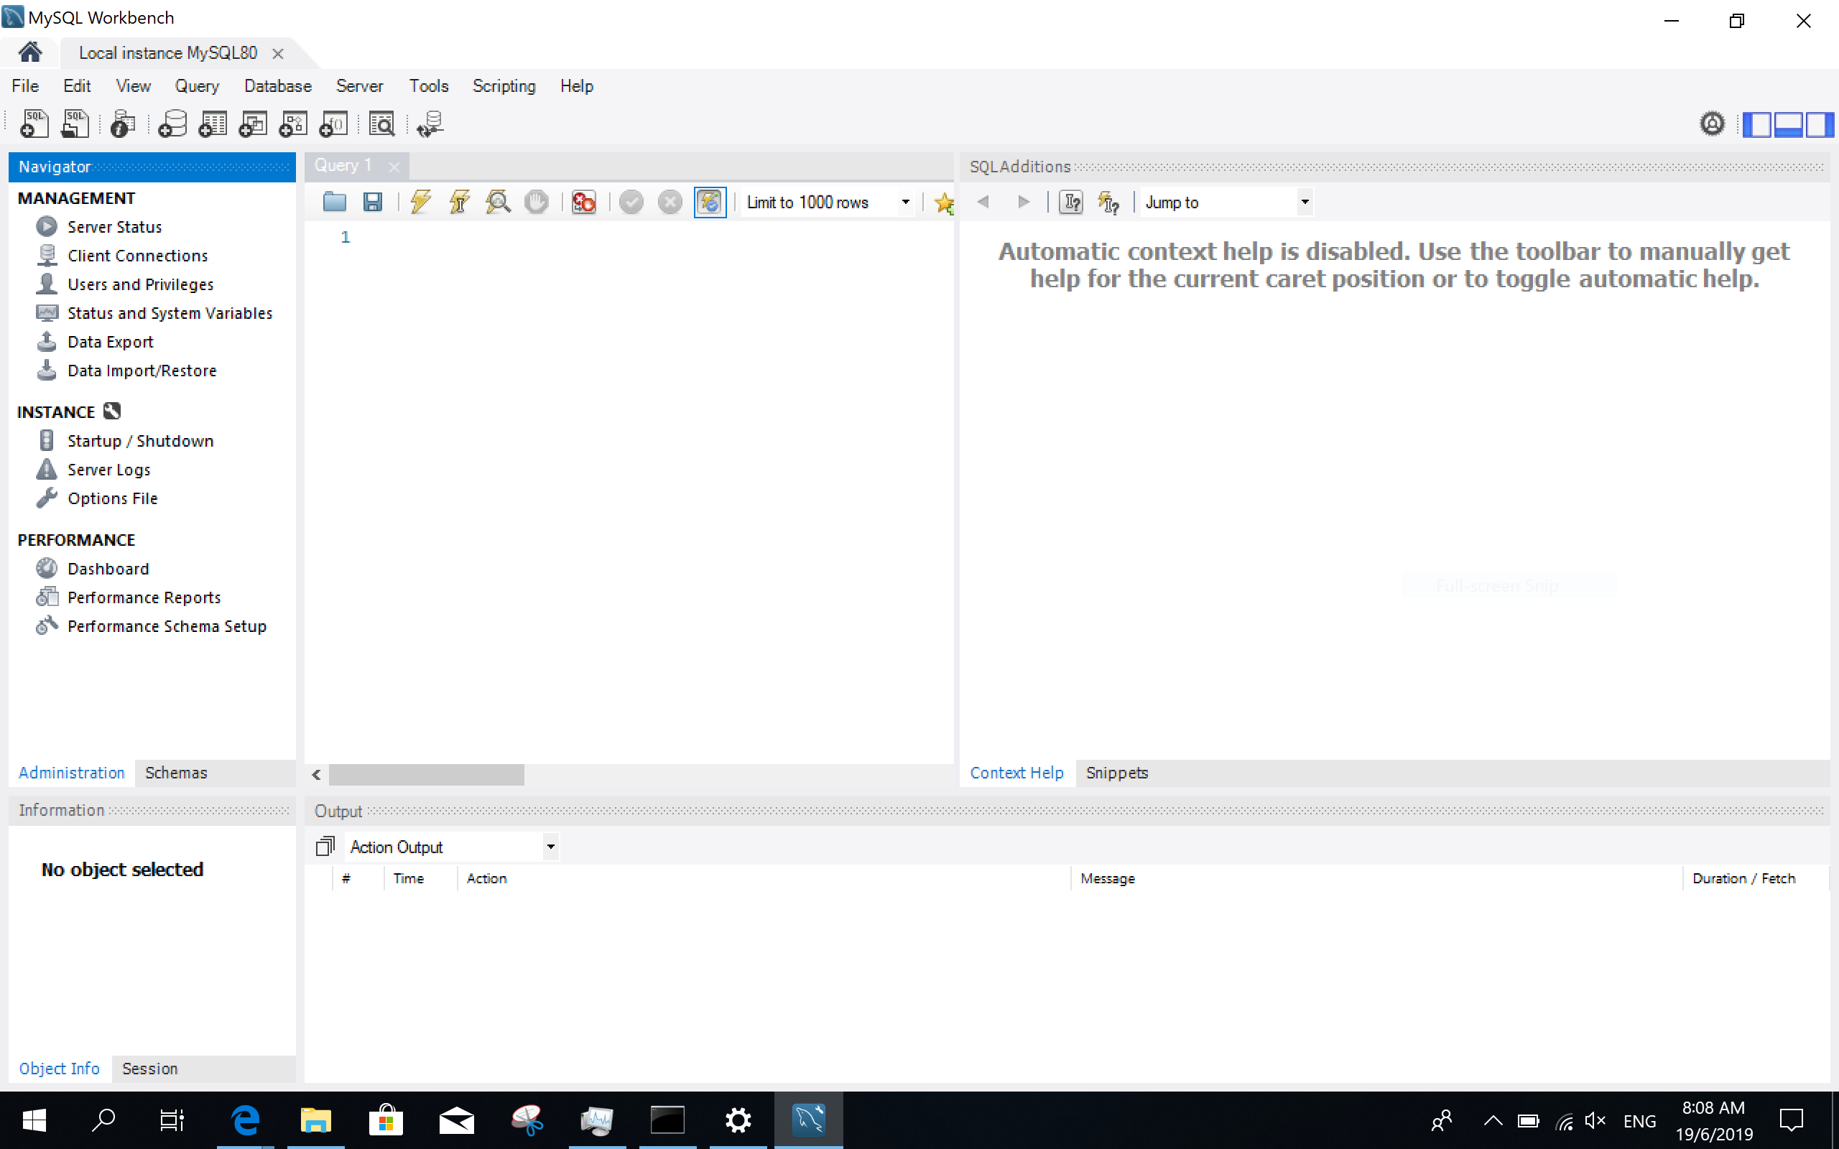

We have now successfully connected to our database server from the workbench.